

My little aquarium

CSIS 1280 Final Project



Student: Phan Vo

Student ID: 300320809

Course: CSIS-1280-001_23124_202020 Multimedia Web Development

Instructor: Bambang Sarif

Table of Contents

**Introduction** 2

**Website organization** 2

**Website layout documentation** 2

**Highlights** 6

**Content declaration** 7

**References** 7

# **Introduction**

For the final project, I want to take this chance to express my enthusiasm in developing a website with the marine life theme. Inspired by the charming ocean with several beautiful species, I love to research their interesting facts such as how they survive in the deep blue sea (e.g. as a predator or a prey) and what their behaviors are when hunting or escaping dangers (e.g. aggressive or passive). They are just a few examples that I want to share on the website currently. With the probability of extending in the future, I want to make my website a fun place to learn new knowledge and support marine life community.

# **Website organization**

Thanks to the knowledge and research skills I gain through the course, I can combine the content, presentation, and behaviors of elements to develop the entire website using HTML5, CSS3 and JavaScript. Technically, the website consists of 3 main pages:

* Home page: few words about the main theme and functions of the website. In addition, a list of available marine animals is displayed with their names and images.
* Explore page: details about each marine animal introduced at the home page, along with fun facts and videos.
* Contact page: information about the address; form for users to contact with the author about different topics.

In addition, each of the above pages was implemented accordingly to responsive designs for mobile, tablet and desktop layout to optimize content display and easy navigation.

# **Website layout documentation**

Generally, each page contains header, navigation, article, and footer HTML element to serve different purposes as follows:

* Header: contains website title, theme, cool icons, and date/time features using JavaScript and CSS with absolute position. The text and icons in the header are styled in center using flex. The fish icon is basically one single icon, and its mirror icon was created using CSS transform.
* Navigation: contains links to different pages (i.e. Home, Explore, and Contact page) with hover and color effects using CSS when user moves mouse over links.
* Article: contains sections, one of which introduces few words about the current page or extra features (i.e. video, audio); and the rest contains animal information
* Footer: contains author information such as name, id and course taken.

All the above HTML elements were styled using CSS and JavaScript with respect to responsive designs of mobile, tablet and desktops. As a result, some layouts are redesigned to fit different screen sizes. For example, desktop layouts (i.e. Figure 1, 2, 3) have more screen width, so I can create a left-side navigation with page links, and article on the right-side. However, tablet layouts (i.e. Figure 1.1, 2.1, 3.1) have limited screen width, so the navigation bar with page links has been moved to the top, just below header, instead of the left side. Similarly, for mobile layouts (i.e. Figure 1.2, 2.2, 3.2), the top navigation bar is still maintained, but all page links are hidden due to small screen width. Instead, I implemented hamburger menu using JavaScript to show/hide page links as needed.

The layout of each page is designed using CSS grid layout to adapt different screen size and HTML element changes. I tried to research more grid techniques using grid-template-columns and grid-template-area to achieve better layout controls. The website theme was designed with appropriate color palettes, mainly dark blue for ocean colors, with reference to the guidelines of colorhunt and paletteton website.

At Home page (i.e. Figure 1), each animal image contains a link to its corresponding information at Explore page using ID matching to jump to the correct page position. Next, at Explore page (i.e. Figure 2), user can learn knowledge about animals mentioned at the Home page with videos and fun facts using iframes and blockquotes, respectively. Finally, to keep in touch with the author or want to make requests, the Contact page (i.e. Figure 3) contains a form, which uses CSS inline validation and JavaScript constraint validation API, to support different topics. Also, I used fakeaddressgenerator website to generate the fake address given in the Contact page. One more interesting thing at the Contact page is that the address image can be randomly changed to different animals every time the user visits, which invokes the implementation of JavaScript array and random number function.

Below are all figures mentioned in this part. They are screenshots taken directly from my website.

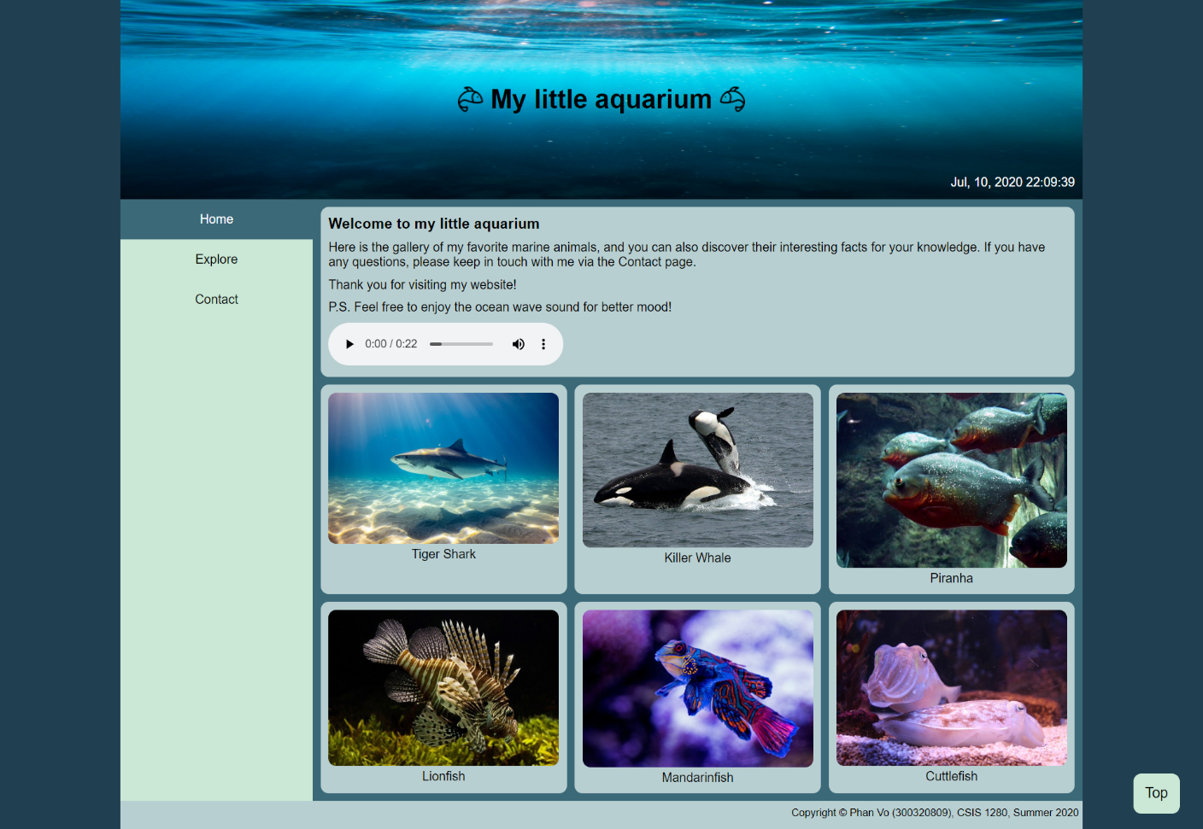

Figure 1 – Home page (desktop layout)

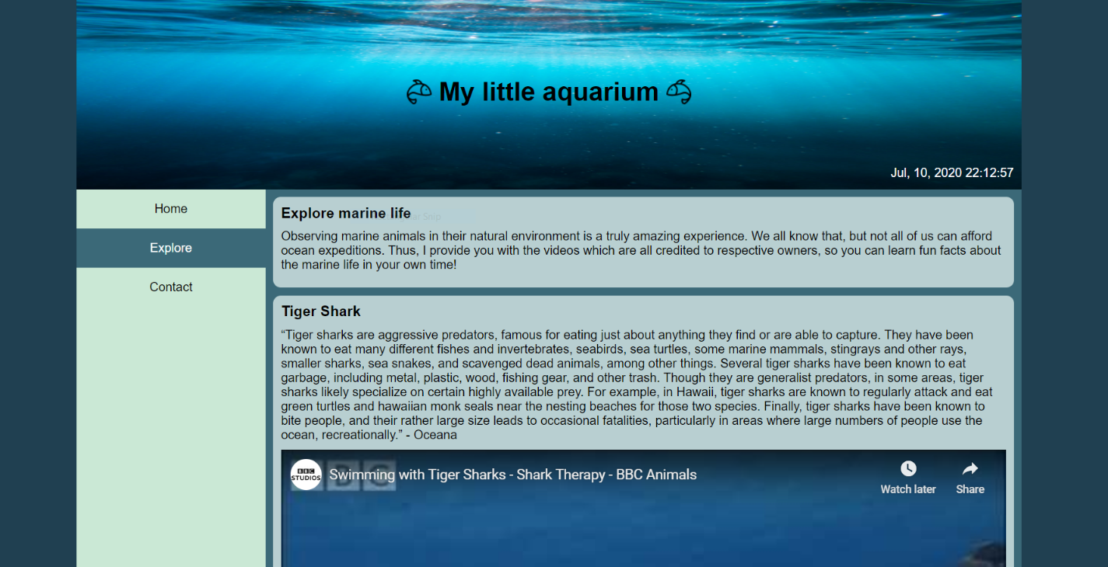

Figure 2 – Explore page (desktop layout)

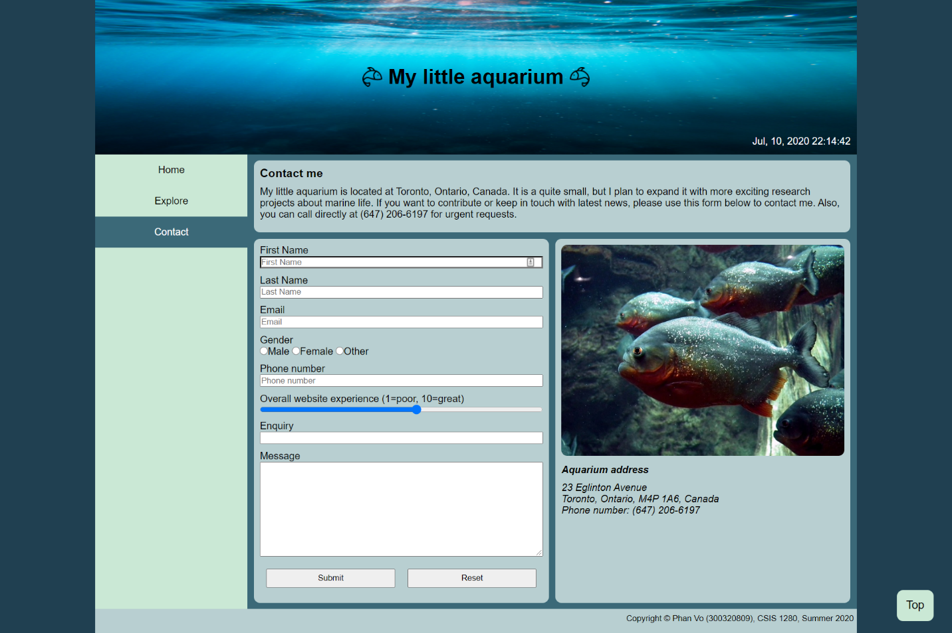

Figure 3 – Contact page (desktop layout)

|  |  |
| --- | --- |
| Figure 1.1 – Home page (Tablet layout) | Figure 1.2 – Home page (Mobile layout) |

|  |  |
| --- | --- |
| Figure 2.1 – Explore page (Tablet layout) | Figure 2.2 – Explore page (Mobile layout) |

|  |  |
| --- | --- |
| Figure 3.1 – Contact page (Tablet layout) | Figure 3.2 – Contact page (Mobile layout) |

# **Highlights**

Besides contents, the website was carefully designed to improve user experiences by using different techniques such as navigation bar flexibility and its usability in different responsive designs. For example, regarding table and mobile layouts, navigation bar is sticky at the top using CSS so that user can navigate back and forth between pages easily. Moreover, in mobile design, the hamburger menu was implemented using JavaScript to hide/show page links as needed and to facilitate switching different pages in the small screen.

Furthermore, in desktop layout, when scrolling in such a long page, items in the left-side navigation bar will be no longer visible. To solve that, a “back to top” button was implemented at the bottom-right for easy navigation, so user can see available items at the left-side navigation bar. Also, that button will be dynamically hidden or visible using JavaScript, which is based on the estimated calculation of the total height of available items in the navigation bar.

Sometimes, when users spend time on surfing the website, he/she might forget other important ongoing events. For that reason, a small date and time feature was implemented using JavaScript in the header of all pages. Thus, user can be aware of the current time and date, which is updated in real-time, while still enjoying the website.

In the Contact page, the address image will be randomly changed to different animals every time he/she visits the page, which helps refresh user experience.

# **Content declaration**

1. **Images used:**

Hamburger menu icon

<https://www.iconfinder.com/icons/134216/hamburger_lines_menu_icon>

Invalid icon

<https://www.flaticon.com/free-icon/remove_1828843?term=cross&page=1&position=9>

Valid icon

<https://www.flaticon.com/free-icon/check_845646?term=tick&page=1&position=3>

Header image – Ocean background

<https://unsplash.com/photos/XexawgzYOBc>

Header image – Fish icon

<https://www.flaticon.com/free-icon/fish_3050536?term=fish&page=1&position=27>

Killer Whale

<https://pixabay.com/photos/killer-whales-orcas-breaching-1945411/>

Cuttlefish

<https://pixabay.com/photos/cuttlefish-fish-sea-creatures-800340/>

Tiger Shark

<https://unsplash.com/photos/GBDkr3k96DE>

Lionfish

<https://pixabay.com/photos/lionfish-aquarium-sealife-tropical-711799/>

Mandarinfish

<https://unsplash.com/photos/xNpxB9bfLUE>

Piranha

<https://pixabay.com/photos/piranha-fish-aquarium-animals-262575/>

1. **Videos used:**

Killer Whale

<https://youtu.be/qPDZZj6By3Y>

Cuttlefish

<https://youtu.be/AjS2-Ftj_K4>

Tiger Shark

<https://youtu.be/q8fvw3JDMw0>

Lionfish

<https://youtu.be/XqGhsMhZtF0>

Mandarinfish

<https://youtu.be/KivINH0ka_A>

Piranha

<https://youtu.be/fSqbqDhDYZo>

1. **Audio used:**

Ocean waves sound

<http://soundbible.com/338-Beach-Waves.html>

1. **Animal facts in Explore page:**

Tiger Shark

<https://oceana.org/marine-life/sharks-rays/tiger-shark>

Killer Whale

<https://oceana.org/marine-life/marine-mammals/orca>

Piranha

<https://www.britannica.com/animal/piranha-fish>

Lionfish

<https://oceanservice.noaa.gov/facts/lionfish-facts.html>

Mandarinfish

<https://www.georgiaaquarium.org/animal/mandarinfish/>

Cuttlefish

<https://www.mba.ac.uk/fact-sheet-cuttlefish>

# **References**

Learn several grid layout techniques

<https://css-tricks.com/snippets/css/complete-guide-grid/>

Create sticky navigation bar

<https://www.w3.org/WAI/WCAG21/Techniques/css/C34.html>

Create mobile menu for navigation bar

<https://www.w3schools.com/howto/howto_js_mobile_navbar.asp>

How to override a style, used to control responsive pages

<https://stackoverflow.com/questions/104485/is-there-a-way-to-force-a-style-to-a-div-element-which-already-has-a-style-at>

How to scroll back to top

<https://www.w3schools.com/howto/howto_js_scroll_to_top.asp>

Style element height in JS

<https://www.w3schools.com/jsref/prop_style_height.asp>

<https://developer.mozilla.org/en-US/docs/Web/API/Document/height>

Format phone number

<https://learnersbucket.com/examples/javascript/how-to-format-phone-number-in-javascript/>

Learn and test regex validations

<https://regexr.com/>

Email regex validation

<https://www.w3schools.com/tags/att_input_pattern.asp>

YouTube iframe responsive

<https://www.h3xed.com/web-development/how-to-make-a-responsive-100-width-youtube-iframe-embed>

YouTube iframe issue of overlapping sticky navigation bar

<https://stackoverflow.com/questions/59388943/youtube-iframe-is-shown-over-the-position-sticky-css-div>

Fake address and phone number generator

<https://www.fakeaddressgenerator.com/World/ca_address_generator>

Mirror image effect

<https://www.w3schools.com/howto/howto_css_flip_image.asp>

Website color palettes

<https://colorhunt.co/palette/177866>

<https://paletton.com/#uid=13k0u0k7yAp1gVD3VMhc2tahunT>

Display clock

<https://www.w3schools.com/js/tryit.asp?filename=tryjs_timing_clock>

Display and format current date

<https://stackoverflow.com/questions/3552461/how-to-format-a-javascript-date>

Random value in an array

<https://stackoverflow.com/questions/4550505/getting-a-random-value-from-a-javascript-array>